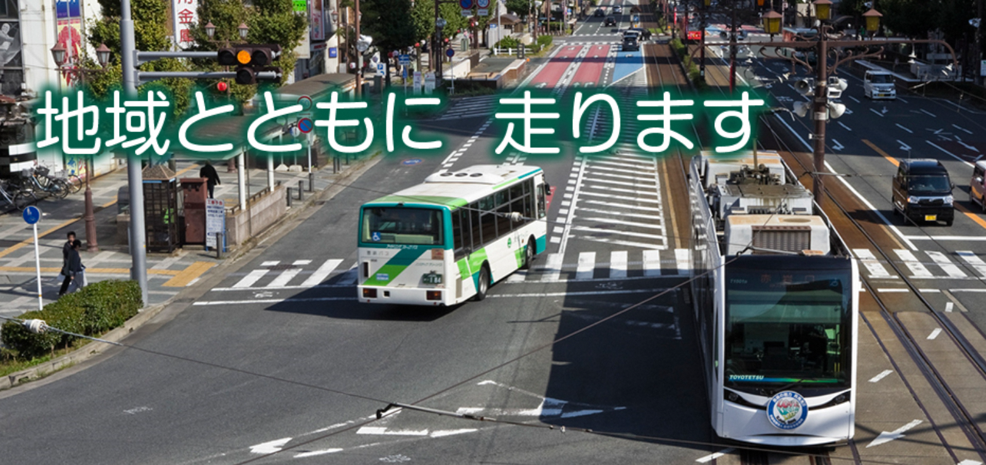
Let’s go out with Toyutetsu Bus
To all International students!

- Project outline
Toyohashi International Association (TIA) gives students living in Toyohashi
frequent knowledge of Toyohashi and gives international students who live in
the city a coupon ticket for Toyohashi Bus in order to participate in various social activities.

- Applicable international students
International students from 3 universities in the city and living in Toyohashi City.
(Aichi University, Toyohashi University of Technology and Toyohashi Sozo University)

- Number of tickets to be issued
23 pieces of 100 yen bus tickets will be issued and up to 4 sets of ticket will be given per person.

- How to apply
Please apply to Toyohashi International Association (TIA) by filling up the application form
at the back. (Only applications for the first bus ticket will be accepted by this application form.)

- Precautions
- Only bus tickets that you applied can be used by you. You cannot give it to other people.
- The expiration date is until March 14, 2017. Be sure to return unused tickets to Toyohashi International Association (TIA) by Wednesday, March 14, 2017.

Contact Toyohashi International Association (TIA)
Telephone: 0532-55-3671 Email: tia@tia.aichi.jp
FAX: 0532-55-3674

Please bring this application form directly to Toyohashi International Association
or apply by fax or email.
In case of applying by email please attach the taken photograph of this application form
to the email and apply. You can also download the application form from the following URL.

Application form URL ⇒ http://www.toyohashi-tia.or.jp/
Here is the QR code ⇒

※After applying, we will issue coupon tickets at Toyohashi International Association
※Application for the first set of tickets is accepted at any time by this application form.
Everyone, please use it.

Application Date:
【Requirements】
 |  |  |  | Nationality
Name |  |  |  | Nationality
Address | 〒
School name | Aichi University Toyohashi University of Technology Toyohashi Sozo University  ※Circle the applicable school name
Year |  | Department
Telephone |  | Fax
email

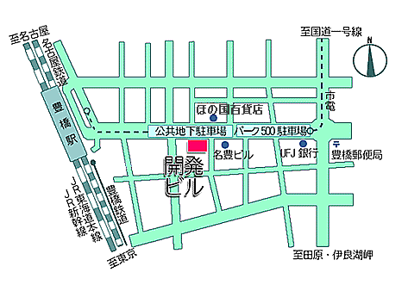
- Precautions
※After receiving this application, we will contact you as soon
as we are ready to handover the bus tickets, please come to
Toyohashi International Association.
（Please bring your student ID card.）

See the map on the right, 3rd floor, Kaihatsu Building
Here is the QR code ⇒

※One set of bus tickets will be handed over to each student.

